## 

## FITFUSION - A SMART FITNESS, DIET

## AND DAILY MOTIVATION

*An Application Development-II Report Submitted*

*In partial fulfillment of the requirement for the award of the degree of*

**Bachelor of Technology *in***

**Computer Science and Engineering**

**(Artificial Intelligence and Machine Learning)**

**by**

**BOCHKAR NIKHITH 22N31A6629**

**AVUDODDI MOUNIKA 22N31A6614**

**BHUKYA KALYAN 22N31A6628**

***Under the esteemed Guidance of***

#### Mrs. N. Radhika

**Assistant Professor**

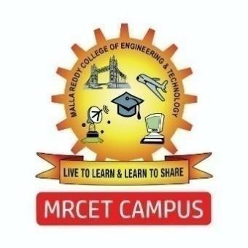

### DEPARTMENT OF COMPUTER SCIENCE AND ENGINEERING

### (ARTIFICIAL INTELLIGENCE AND MACHINE LEARNING)

**MALLA REDDY COLLEGE OF ENGINEERING AND TECHNOLOGY**

#### (Autonomous Institution – UGC, Govt. of India)

**(Affiliated to JNTU, Hyderabad, Approved by AICTE, Accredited by NBA & NAAC – ‘A’ Grade, ISO 9001:2015 Certified)** Maisammaguda (v), Near Dullapally, Via: Kompally, Hyderabad – 500 100, Telangana State, India. website: [www.mrcet.ac.in](http://www.mrcet.ac.in)

#### 2024-2025